** The information contained in this document is for Educational Purposes ONLY **
Name: Opinder Jain Age: 28 yrs
Expected Rate of Return: 12.00% Capital Gain Tax Rate: 12.50%

Withdrawal Amount Information
Age | Description | Amount | SIP Amount Invested
33 | Car | Rs. 20,00,000 | Rs. 15,29,331
41 | Education 4 | Rs. 20,00,000 | Rs. 9,38,051
41 | Education 1 | Rs. 20,00,000 | Rs. 9,38,051
54 | Education 2 | Rs. 50,00,000 | Rs. 9,07,857
54 | Education 3 | Rs. 35,00,000 | Rs. 6,35,500
58 | Marriage | Rs. 20,00,000 | Rs. 2,62,692
60 | OldAge Home | Rs. 1,60,00,000 | Rs. 17,79,138

SIP Amounts Required
Investment Age | Monthly SIP Amount
Till Age 33: | Rs. 64,798
Between Age 33 & 41: | Rs. 39,309
Between Age 41 & 41: | Rs. 27,282
Between Age 41 & 54: | Rs. 15,256
Between Age 54 & 54: | Rs. 10,310
Between Age 54 & 58: | Rs. 5,363
Between Age 58 & 60: | Rs. 4,633

Corpus Value by Age
Age | Corpus Value | Age | Corpus Value | Age | Corpus Value
29 | Rs. 6,10,554 | 40 | Rs. 68,81,570 | 51 | Rs. 1,37,67,471
30 | Rs. 12,94,374 | 41 | Rs. 79,92,508 | 52 | Rs. 1,55,51,184
31 | Rs. 20,60,252 | 42 | Rs. 42,63,402 | 53 | Rs. 1,75,48,943
32 | Rs. 29,18,036 | 43 | Rs. 49,06,627 | 54 | Rs. 1,97,86,433
33 | Rs. 38,78,755 | 44 | Rs. 56,27,039 | 55 | Rs. 1,15,96,207
34 | Rs. 23,14,048 | 45 | Rs. 64,33,900 | 56 | Rs. 1,30,56,217
35 | Rs. 28,76,885 | 46 | Rs. 73,37,585 | 57 | Rs. 1,46,91,428
36 | Rs. 35,07,261 | 47 | Rs. 83,49,711 | 58 | Rs. 1,65,22,864
37 | Rs. 42,13,283 | 48 | Rs. 94,83,293 | 59 | Rs. 1,60,46,788
38 | Rs. 50,04,027 | 49 | Rs. 1,07,52,905 | 60 | Rs. 1,80,31,552
39 | Rs. 58,89,660 | 50 | Rs. 1,21,74,870

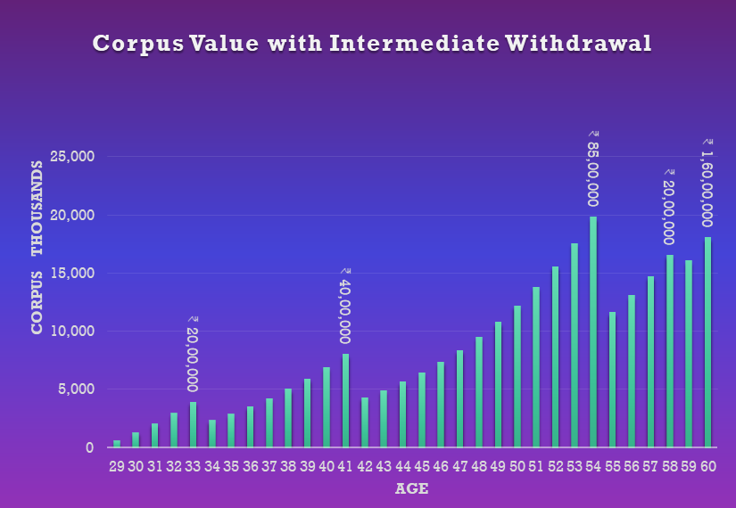

Total SIP Invested: Rs. 69,90,620

Total Amount Withdrawn: Rs. 3,25,00,000

Total Capital Gain Tax Paid: Rs. 33,90,253

Thank you for reviewing the customized Withdrawal Planner. We appreciate your trust in Nivra Fintech and remain committed to providing high-quality, goal-oriented financial solutions. Please contact us should you require any further assistance.

Nivra Fintech Team!
The Financial Engineers

